**Hardware Requirements Standards  
  
  
 For The  
  
Avionics Passenger Counter**

Document No: 800-HRS-01

Revision: A

|  |  |  |  |
| --- | --- | --- | --- |
| __________________________________________________ |  | | ___________ |
| Project Manager |  | Date | |
| __________________________________________________ |  | ___________ | |
| Technical Project Lead |  | Date | |
| __________________________________________________ |  | ___________ | |
| Principal Design Engineer |  | Date | |
| __________________________________________________ |  | ___________ | |
| Principal Quality Engineer |  | Date | |

|  |
| --- |
| **Notice**  This document and the information contained herein are the property of Airworthiness Certification Services LLC. Any reproduction, disclosure or use thereof is prohibited except as authorized in writing by Airworthiness Certification Services LLC. Recipient accepts the responsibility for maintaining the confidentiality of the contents of this document. |

|  |  |  |  |
| --- | --- | --- | --- |
| REVISIONS | | | |
| Rev. | Reason/Description | Requested/ Changed By | Date |
| A | Initial Release | JB | 1/1/20 |
|  |  |  |  |
|  |  |  |  |
|  |  |  |  |
|  |  |  |  |
|  |  |  |  |
|  |  |  |  |
|  |  |  |  |
|  |  |  |  |
|  |  |  |  |
|  |  |  |  |
|  |  |  |  |
|  |  |  |  |
|  |  |  |  |
|  |  |  |  |
|  |  |  |  |
|  |  |  |  |
|  |  |  |  |
|  |  |  |  |
|  |  |  |  |
|  |  |  |  |
|  |  |  |  |
|  |  |  |  |
|  |  |  |  |
|  |  |  |  |
|  |  |  |  |
|  |  |  |  |
|  |  |  |  |

**Table of Contents**

**Section Page**

1.0 INTRODUCTION 4

1.1 Purpose 4

1.2 Scope 4

1.3 Acronyms and Abbreviations 5

1.4 Applicable Documents 6

1.4.1 External Documents 6

1.4.2 Internal Documents 6

2.0 HARDWARE REQUIREMENTS STANDARDS 7

2.1 Characteristics of Requirements Data 9

2.1.1 Unambiguous 9

2.1.2 Complete 9

2.1.3 Verifiable 9

2.1.4 Consistent 9

2.1.5 Modifiable 9

2.1.6 Traceable 10

2.1.7 Unique 10

3.0 DEVELOPMENT METHODS 11

3.1 System Level Requirements 11

3.1.1 System Level Requirements Output 11

3.2 High-Level Hardware Requirements 12

3.2.1 Input Requirements 12

3.2.2 Functional Requirements 12

3.2.3 Output and Performance Requirements 13

3.2.4 Timing Requirements 13

3.2.5 High Level Hardware Requirement Review Criteria 13

3.2.6 High-Level Software Requirements Tool Output 14

4.0 REQUIREMENTS NOTATION 15

4.1 System Level Requirement Notation 15

4.1.1 System Level Place Holder for Derived Requirements 15

4.1.2 System Level Requirements Identification 15

4.2 High-Level Hardware Requirements Notation 16

4.3 Derived Hardware Requirements Notation 16

5.0 DERIVED HARDWARE REQUIREMENTS 17

5.1 Output of Derived Hardware Requirements That ***Are Not*** Traceable 17

5.2 Output of Derived Hardware Requirements That ***Are*** Traceable 17

6.0 REQUIREMENTS DEVELOPMENT TOOLS 18

6.1 Requirements Traceability Management System 18

# INTRODUCTION

## Purpose

This plan describes the Hardware Requirements Standards and has been prepared in accordance with the requirements of RTCA/DO-254.

## Scope

This standard will be used during the requirement definition process to define the methods, rules, and tools to be used to develop the high-level requirements. Once approved, it is implemented during the development and product life cycle of the deliverable airborne Hardware. This Hardware Requirements Standards document complies with the documentation requirements of RTCA/DO-254.

## Acronyms and Abbreviations

<PROJ> <Add Project Acronyms in Alphabetical Order>

AIMS Action Item Management System

ALU Arithmetic Logic Unit

ARP Aerospace Recommended Practice

ASIC Application Specific Integrated Circuit

DRMS Document Review Management System

HAS Hardware Accomplishment Summary

HC1 Hardware Control Category 1

HC2 Hardware Control Category 2

COTS Commercial-Off-The-Shelf

EUROCAE European Organization for Civil Aviation Equipment

FAR Federal Aviation Regulations

FFP Functional Failure Path

FFPA Functional Failure Path Analysis

FHA Functional Hazard Assessment

F-FMEA Functional Failure Modes and Effects Analysis

FTA Fault Tree Analysis

HDL Hardware Description Language

JAR Joint Aviation Requirements

LRU Line Replaceable Unit

PHAC Plan for Hardware Aspects of Certification

PLD Programmable Logic Device

PSSA Preliminary System Safety Assessment

RTMS Requirements Traceability Management System

SAE Society of Automotive Engineers

SC Special Committee

SSA System Safety Assessment

WG Working Group

## Applicable Documents

The following documents are listed for reference only. Each document is applicable to this plan only to the extent specified herein.

### External Documents

RTCA/DO-254 Design Assurance for Airborne Electronic Hardware

FAA Order 8110.4C Type Certification

FAA Order 8110.105 FAA, Simple and Complex Electronic Hardware Approval Guidance

AC 20-152 Advisory Circular, RTCA Inc., Document DO-254, Design Assurance for Airborne Electronic Hardware

### Internal Documents

None Referenced

# HARDWARE REQUIREMENTS STANDARDS

The purpose of the Hardware Requirements Standards is to define the methods, rules, and tools to be used to develop the high-level requirements. This includes, but may not be limited to:

* The methods to be used for developing Hardware requirements
* Notations to be used to express requirements, such as data flow diagrams and formal specification languages.
* Constraints on the use of requirements development tools
* The method to be used to provide derived requirements to the system process

All System Requirements are analyzed, including functional, safety, and interface requirements allocated to Hardware and translate the same into Hardware High Level Requirements. The objective of this analysis is to:

* Ensure that system requirements allocated to hardware and Hardware do not have ambiguities, inconsistencies, or undefined conditions. Clarification, if any, will be made from requirement source and system life cycle processes.

High Level Requirements include functional requirements, safety requirements, interface requirements, capability requirements, data element requirements, adaptation requirements, programming requirements, design constraints, human factor requirements, and algorithmic requirements.

The Hardware Requirements Document lists all high-level Hardware requirements, including requirements with safety implications. With the exception of derived requirements, all High Level Requirements are traceable to one or more System Requirements.

Requirements Definition / Traceability Flow

The following diagram details the requirements definition and traceability process.

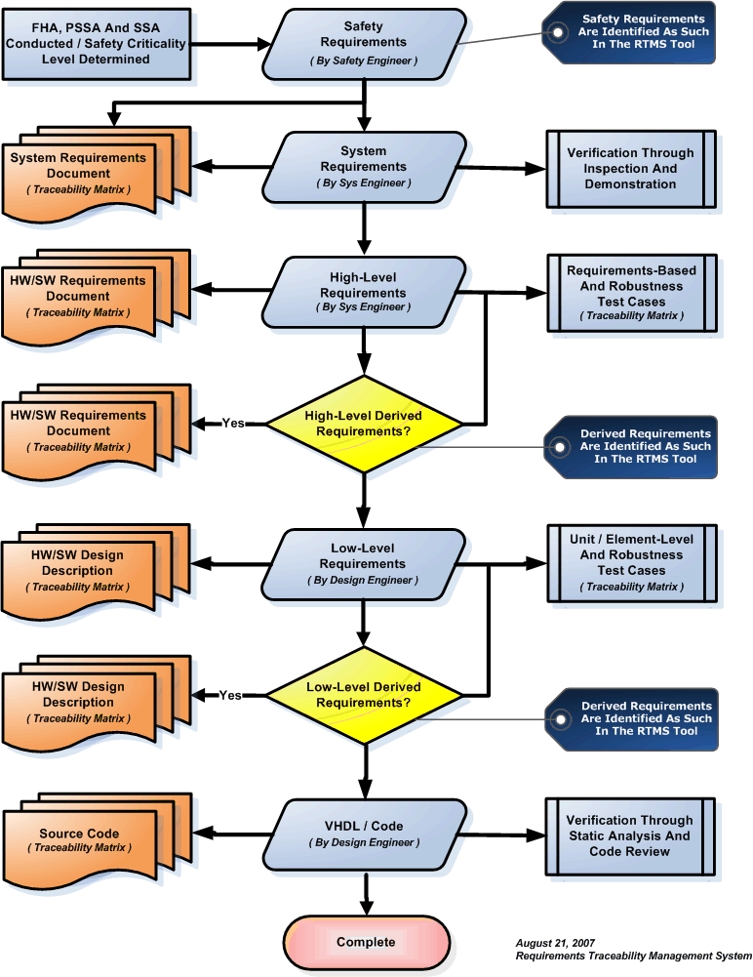

## Characteristics of Requirements Data

The purpose of the hardware Requirements Data is to correctly define all the hardware requirements. It shall not describe design or verification details, except for required design constraints. The hardware Requirements Data shall limit the range of valid solutions but shall not specify particular design, thus providing the engineer with flexibility. The hardware Requirements Data shall be unambiguous, complete, verifiable, consistent, modifiable, traceable, and usable during the operational life of the hardware, and the requirements shall be uniquely defined. In order to facilitate these characteristics, the project will store all requirements in the RTMS requirement tool. The hardware Requirements Data will be generated from the RTMS tool/database. Each of these characteristics is described in the following paragraphs.

### Unambiguous

The hardware Requirements Data is unambiguous if every requirement stated has only one interpretation. This requires that each characteristic of the final product be described using a single unique term.

### Complete

The hardware Requirements Data is complete if it:

* Includes all significant requirements relating to functionality, performance, design constraints, and external interfaces.
* Contains full labeling and referencing of all its figures, tables, and diagrams, and defines all terms and units of measure.
* Conforms to these hardware Requirements Standards.

### Verifiable

The hardware Requirements Data is verifiable if there is a finite, cost-effective method by which a person or machine can check that the hardware meets the requirements.

### Consistent

The hardware Requirements Data is consistent if no sets of individual requirements are in conflict. Requirements in conflict might:

* Use different terms for the same object.
* Specify different characteristics for the same object.
* Specify illogical or impossible relationships between actions.

### Modifiable

The hardware Requirements Data is modifiable if its structure and style are such that any necessary changes can be made easily, completely, and consistently. This generally requires the hardware Requirements Data to have a coherent and easy-to-use organization, with a table of contents and an optional index. In addition, it shall not be redundant, i.e.: the same requirement shall not appear in more than one place, since this could lead to errors later if the requirement needs to be modified. The use of the RTMS tool allows requirements data to be easily modifiable, while maintaining traceability.

### Traceable

The hardware Requirements Data is traceable if its corresponding requirements in the system specification are clear (backward traceability) and if it facilitates the referencing of each requirement in the design and verification data (forward traceability). Backward traceability depends on each requirement referencing its source in previous documents. Forward traceability depends on each requirement in the hardware Requirements Data having a unique name or reference number. RTMS accomplishes both forward and backward traceability.

### Unique

The hardware requirements shall be distinctively defined such that each requirement statement consists of a single requirement and a single reference tag number. RTMS only allows a single reference tag per requirement.

# DEVELOPMENT METHODS

Structured methods will be used to perform requirements identification and traceability. These methods will result in the identification and traceability of System Level Requirements, High-Level Hardware Requirements, Low-Level Hardware Requirements, and Derived Hardware Requirements. Using this method, requirements will be written that are unambiguous, consistent, and verifiable.

## System Level Requirements

System requirements are inspection requirements (i.e., weight, measurement, power, etc.) and categories for high-level requirements (i.e., the system shall support ARINC 429 messages). System requirements are not verifiable through Test or Analysis. Engineering is responsible for producing the System Requirements Document. This document is the starting point for requirement definition and traceability.

System requirements are categorized into the following types:

* Industry Requirement
* Regulatory Requirement
* Customer Requirement
* System Driven Requirement
* Mechanical Requirements

### System Level Requirements Output

The RTMS tool will output each system requirement in a table format (see example below). The table will include the unique system requirement number, category, system requirement, source of the requirement, and will identify if the requirement is safety related.

|  |  |  |
| --- | --- | --- |
| **SYS 01** | **Type:** | Regulatory |
|  | |
| Derived requirements shall be identified and verified | | |
| **Req Source:** | RTCA/DO-254 | |
| **Safety Related:** | False | |

|  |  |  |
| --- | --- | --- |
| **SYS 002** | Type: | Customer |
|  | |
| The System SHALL support analog and discrete data. | | |
| **Req Source:** | PTS-1234.1 | |
| **Safety Related:** | True | |

## High-Level Hardware Requirements

High-level requirements are those requirements that are developed from analysis of the system requirements, safety-related requirements, and system architecture. High-level Hardware requirements are written as individually testable requirements. Special focus will be given to high-level requirements, as they form the basis for requirements-based testing.

In order to facilitate better hardware design, the requirements analysis should proceed systematically; aggregating functionally-related requirements together. Scattered requirements tend to produce descriptions that are either redundant or inconsistent. Since any hardware consists of inputs, processing, and outputs, it is convenient to classify requirements into input requirements, computational requirements, and output requirements. Putting the requirements in this logical order actually helps maintain the correlation between the hardware Requirements Data and the hardware Design Data. High-level requirements are identified with the following categories:

### Input Requirements

List or reference the appropriate interface documents for all analog, discrete, and serial digital inputs to the system. List or reference the appropriate interface documents for all the inputs to the hardware from external interface devices. For all inputs, listed or referenced, state the voltage, current, and frequency. State the pre-processing requirements for all inputs. This covers de-bouncing for discrete inputs. Describe the algorithms to be used. Use logical notation and flow charts as necessary. Enter all this requirements data into RTMS.

### Functional Requirements

Once the requirements for the inputs to the hardware are captured, the definition functional requirements may begin. The functional requirements describe in detail the functions to be performed by the system. Describe the designs that are used to meet the functional requirements. Describe the built-in test requirements. Enter all this requirements data into RTMS.

### Output and Performance Requirements

Finally specify the output and performance requirements of the hardware. List or reference the appropriate interface document all discrete and serial digital outputs specifying their voltage, current, frequency, and the rate of update. Enter all this requirements data into RTMS.

### Timing Requirements

The interactions between the hardware and associated IC devices are subject to timing constraints. List all of the setup/hold times and frequency constraints from IC data sheets. Enter the timing constraint data into RTMS.

### High Level Hardware Requirement Review Criteria

As the hardware requirements are expressed in text, the use of unambiguous words and correct language are essential. Pre-release reviews of the hardware Requirements Data shall use the following criteria:

* Watch for persuasive connectors such as ***certainly***, ***therefore***, or ***obviously***, and ask why they are present.
* Ensure vague terms such as ***some***, ***usually***, or ***most*** are clarified. However, avoid the use of vague terms as a general rule.
* Look for statements containing ***always***, ***every***, ***never***, or other terms that imply certainty and ask for proof.
* Ensure lists are complete. Eliminate use of phrases like ***etc***., and ***so on***, or ***such as***.
* Beware of vague verbs such as ***handled***, ***processed***, or ***eliminated*** that can be interpreted in many ways.
* Always include units in stated ranges of variables.
* When a term is explicitly defined in one place, make sure that definition applies for other occurrences of the same term.
* If necessary, when a structure is described in words, draw a picture or a table to aid in understanding it.
* When a series of logical conditions are stated, consider the use of formal notation, logic and/or flow diagrams as a more effective way of expression.

### High-Level Software Requirements Tool Output

The RTMS tool will output each high-level and derived hardware requirement in a table format (see example below). The table will include the unique high-level hardware requirement number, type, hardware requirement, source of the requirement, and will identify if the requirement is safety related. Once the requirements-based test cases are developed, they will be cross-referenced to each high-level requirement. This will be used as the basis for determining the extent of test coverage.

High-Level Requirement Output Examples

x.x   Regulatory Compliance

|  |  |
| --- | --- |
| 001.0001 | Derived requirements shall be identified and verified |

x.x   States and Modes

|  |  |
| --- | --- |
| 001.0005 | The hardware SHALL determine whether the aircraft is in the landing flight phase based on the inputs (Altitude, Gear Down, and Airspeed) that are valid for the current configuration. |

x.x.x   States

|  |  |
| --- | --- |
| 000.0000 | No Requirements |

x.x.x   Modes

|  |  |
| --- | --- |
| 002.0004 | The hardware shall be able to collect parameters from up to fifty separate and unique discrete signals. |

|  |  |
| --- | --- |
| 003.0006 | The hardware SHALL indicate that the landing phase has started when the aircraft altitude is less than 1500 feet (with 100 feet of hysteresis) and the aircraft landing gear is down. |

# REQUIREMENTS NOTATION

## System Level Requirement Notation

### System Level Place Holder for Derived Requirements

|  |  |  |
| --- | --- | --- |
| **System** | **HL Hardware** | **Description** |
| **01** |  | Place Holder For Derived Requirements |

### System Level Requirements Identification

System level requirements are identified as one-up numbers between 02 and 99.

|  |  |  |
| --- | --- | --- |
| **System** | **HL Hardware** | **Description** |
| **02** |  | First System Level Requirement |
| .  .  . |  | On-Up Numbering |
| **99** |  | Last System Level Requirement |

## High-Level Hardware Requirements Notation

High level requirements are identified as one-up numbers between 002 and 999.

|  |  |  |
| --- | --- | --- |
| **System** | **HL Software** | **Description** |
| 02 | **002** | First High Level Hardware Level Requirement |
| 03 | **003** | Second High Level Hardware Level Requirement |
| 03 | **004** | Third High Level Hardware Level Requirement |
| 03 | **005** | Forth High Level Hardware Level Requirement |
| 03 | **006** | Fifth High Level Hardware Level Requirement |
| 04 | **007** | Sixth High Level Hardware Level Requirement |
| 04 | **008** | Seventh High Level Hardware Level Requirement |

## Derived Hardware Requirements Notation

High-Level derived requirements are identified using the system level placeholder [01] and the next applicable one-up reference number at the high-level.

|  |  |  |
| --- | --- | --- |
| **System** | **HL Software** | **Description** |
| **01** | 001 | First Derived HL Software Requirement |
| **01** | 002 | Second Derived HL Software Requirement |
| **01** | 003 | Third Derived HL Software Requirement |
| **01** | 004 | Forth Derived HL Software Requirement |
| **01** | 005 | Fifth Derived HL Software Requirement |

# DERIVED HARDWARE REQUIREMENTS

Derived requirements are those requirements that ***may not*** be directly traceable to higher level requirements. In order to facilitate a logical flow of requirements traceability data, a system level-derived requirement placeholder has been established. This is always the first system level requirement and is identified as 01.

## Output of Derived Hardware Requirements That ***Are Not*** Traceable

|  |  |  |  |  |
| --- | --- | --- | --- | --- |
| **01.001** | **Category:** | Functional & Operational | | |
| **Type:** | Regulatory | | |
| **Sys Requirement ( 01 )** Derived requirements shall be identified and verified. | | | | |
| **HL HW Requirement** The hardware shall do something testable. | | | | |
| **Req Source:** | System Requirements Document | | | |
| **Req Number:** | SYS 01 | | **Paragraph:** | 4.0 |
| **Safety Related:** | False | | **Req Test Case:** |  |
| **Reference:** | Customer Spec 5.12.3 | | | |

## Output of Derived Hardware Requirements That ***Are*** Traceable

|  |  |  |
| --- | --- | --- |
| **03.056** | **Category:** | Functional & Operational |
| **Type:** | Derived |
| **<Same as above>** | | |

# REQUIREMENTS DEVELOPMENT TOOLS

## Requirements Traceability Management System

The Requirements Traceability Management System generates a unique database record for each requirement. Requirements definition is recorded from the System Level to the High Level Hardware Requirements.

The system outputs tables that are directly inserted into the System Requirements Document and Hardware Requirements Document.

